Bad pipelines kill good data.
Even the best datasets become useless if the data pipeline is unreliable, slow, or poorly designed.
The way data moves, transforms, and reaches users determines how useful it actually becomes.
Different business problems require different data pipeline architectures.
Here are 8 types of data pipelines and where they are used.
- Batch Pipelines
Process large volumes of data at scheduled intervals rather than real time. Commonly used for financial reporting, billing systems, and daily analytics dashboards where latency is not critical.
- Streaming Pipelines
Continuously process incoming data with near real-time ingestion and transformation. Ideal for fraud detection, live dashboards, recommendation engines, and IoT monitoring.
- Lambda Architecture
Combines batch and streaming layers to support both historical accuracy and low-latency processing. Often used in large analytics platforms that require real-time insights with reliable batch recomputation.
- Kappa Architecture
A stream-first architecture that removes the batch layer and processes everything as a continuous data stream. Simplifies real-time data processing systems.
- CDC (Change Data Capture) Pipelines
Capture incremental database changes instead of full data loads. Widely used for database replication, audit logs, and near real-time analytics updates.
- Event-Driven Pipelines
Triggered automatically by system events such as API calls, data updates, or user actions. Frequently used in microservices architectures and automation workflows.
- Reverse ETL Pipelines
Move data from warehouses into operational systems like CRMs, marketing tools, and customer platforms to activate analytics inside business workflows.
- Lakehouse Pipelines
Combine data lakes and data warehouses into a unified architecture that supports large-scale analytics, machine learning, and GenAI workloads.
Good analytics depends not just on data quality but also on pipeline architecture, reliability, and latency design.
Which data pipeline architecture is most common in your data stack today?
If this helped, repost and follow Sumit Gupta 📊 for more insights!!
Activate to view larger image,
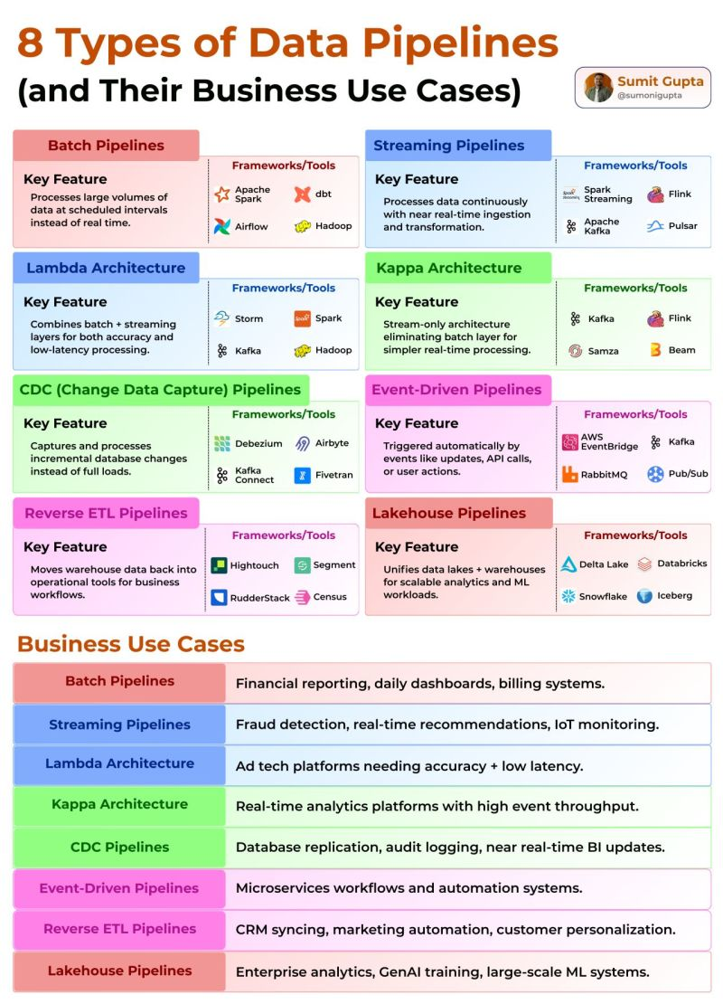

The best data pipeline is not the most complex one. It is the right one for your workload.
Teams often copy architectures they see online, then wonder why costs rise, latency increases, or maintenance becomes painful.
The smarter question is not “What is popular?”
It is “What pattern fits my data, scale, and business need?”
Here are 8 data pipeline patterns every data team should understand 👇
1. ETL (Extract, Transform, Load)
Transform first, then load clean data into storage.
2. ELT (Extract, Load, Transform)
Load raw data first, transform inside modern warehouses.
3. Streaming Pipeline
Process events continuously with very low latency.
4. Lambda Architecture
Combine batch accuracy with real-time speed layers.
5. Kappa Architecture
Use one streaming system for real-time and replay.
6. Micro-Batch Pipeline
Process small batches every few seconds or minutes.
7. Fan-Out Pipeline
Send one source stream to multiple destinations.
8. Event-Driven Pipeline
Trigger downstream actions automatically from events.
How to Choose
• Need dashboards overnight → ETL
• Cloud warehouse analytics → ELT
• Live alerts or fraud detection → Streaming
• Mixed batch + real-time needs → Lambda
• Stream-first systems → Kappa
• Near real-time with simpler ops → Micro-batch
• Multiple consumers → Fan-out
• Workflow automation → Event-driven
What This Means
Architecture decisions directly affect speed, cost, and reliability.
Choose patterns based on outcomes, not trends.
Which pipeline pattern is your team using today?
Follow Sumit Gupta 📊 for more such insights!!
Activate to view larger image,


